الاسم و اللقب :............................. اللغة الانجليزية
Text :
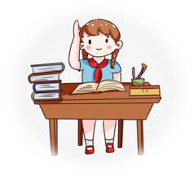 Hi! my name is bochra i’m 8 years old,i live in ain temouchent , i’m 5th year pupil at maghni pramiry school , my father are a doctor at the hospital .and my mom are a teacher and i have a little sister.In my free time i like to learn a new thing and educate my self.
Questions:
1- Read the text then answer the questions:
-how old is bochra?
...............................................................
-where does bochra live?
...............................................................
-is her father a teacher?
...............................................................
2-answer with true or false :
-her mother is doctor ........
-she has two sister ........
-bochra is pupil at primary school ........
3- Match
Bochra Teacher
Father 8 year old
Mother Maghni
Primary school Doctor
4-Reorder the following words :
1-is /my/bochra/name.
…………………………………………………
2-Love/learn/new/I/to/English.
………………………………………………
5- written expression :
In 04 lines describe your school
and use this following words to help you:
Small , big , nice , beautiful , class, school yard , teachers
My school is very nice place……………………….. ………………………………………………………………………………………………………………………………………………………………………………………………………………………………………

